

Market Insight Report
Positioning Emerald Investments for Rising Rates and Elevated Volatility

Report Title: Market Insight Report: Positioning Emerald Investments for Rising Rates and Elevated Volatility
Date: September 30, 2026
Prepared By: Ewan, Sales and Trading Analyst
Client Name: Emerald Investments

Executive Summary
Emerald Investments holds 50% technology, 30% healthcare and 20% cash, with a primary goal of long-term growth, a secondary goal of limiting short-term volatility, and a moderate risk tolerance. Over the most recent seven weeks, the policy interest rate rose from 1.5% to 2.0% and the VIX (a widely used gauge of market nervousness) climbed from 18 to a peak of 25 before settling near 20.
Three findings matter most:
- Volatility, more than rates, hurt technology. Technology lost about 2.3% across weeks 3 to 5 as the VIX rose, then began recovering even while rates kept climbing.
- Healthcare protects, but it does not drive growth. It gained 0.5% over the same weeks with weekly swings about a quarter the size of technology’s, yet it was the weakest sector over the past four quarters (about −2.1% compounded).
- Technology is the portfolio’s main risk. It is 50% of the capital but drives roughly 91% of the portfolio’s weekly ups and downs in this sample.
Recommendation: a measured rebalance, not a retreat. Trim technology to 45%, add 5% financials and 5% consumer goods, and reduce cash to 15% held in short-duration instruments. Agree in advance the triggers for a second step (technology to 40%) or for deploying cash into weakness. Keep energy on a watchlist until the data confirms its recovery.

Key Trends Identified

1. Rates are rising steadily, but were not the main driver of technology’s weakness
The rate moved from 1.5% to 2.0% (up a third) through five separate 0.1-point increases. In the very week the hike was announced (week 2), technology gained 1.5%. Across the seven weeks, technology’s returns show only a weak link to the rate level (correlation −0.24, where 0 means no link and −1 a perfect mirror image; see Figure 3), and a separate monthly rate table shows no consistent pattern either (technology impact of +1.5%, +1.8%, −0.8% and +2.0% as rates rose from 2.5% to 3.25%). Rates remain a risk to monitor, but the recent weakness came from elsewhere.

2. A volatility spike drove the sell-off, and it has only partly reversed
Geopolitical tension (week 3) and technology earnings reports (week 4) pushed the VIX from 18 to 22 and then to its peak of 25. Technology’s weekly return swung from +2.0% in week 1 to −1.0% in week 4, and it moved against the VIX far more closely (correlation −0.78) than against rates. From the end of week 2 to the end of week 5 technology fell about 2.3%; it has since recovered about 1.2%, leaving it roughly 1.1% below its week 2 high. The rebound coincided with a technology earnings beat (week 6) and a new government policy (week 7), and market sentiment moved from negative in weeks 3–4 back to positive in weeks 6–7. The VIX is back to 19–20, still above the starting level of 18.

3. Healthcare held up under stress but has lagged over the year
Healthcare averaged +0.39% a week with typical swings of just 0.29 percentage points, and it was negative in only one week (−0.1%, the VIX peak). The week 5 regulatory event did not dent it (+0.4%). Over the last four quarters, however, healthcare returned −2.3%, −1.4%, +0.5% and +1.1%, about −2.1% compounded. It is improving, but “defensive” describes its stability, not its returns.

4. Technology is still the growth leader, but its momentum is fading
Technology was positive in all four quarters (about +21.4% compounded), yet quarterly growth has slowed from 6.5% in Q2 to 4.3% in Q3 and 3.9% in Q4.

5. Other sectors: consumer goods and financials are steady; energy is unconfirmed
- Consumer goods had no negative quarter and accelerated into Q4 (+4.0%), edging out technology (+3.9%) as the top sector that quarter.
- Financials had the best average weekly return of the four sectors with modest volatility, but they moved almost in step with technology (correlation 0.92, close to lockstep). They offer ballast, not a hedge.
- Energy has improved every week since week 2 (from −1.2% to +2.0% in week 7), yet quarterly returns turned negative in Q3 (−0.8%) and Q4 (−1.1%), and energy is the most volatile sector on that basis. It is also the only sector that tended to move against technology (correlation −0.38), which is its case as a diversifier. The two views conflict, so the recovery is unconfirmed.

Table 1. Weekly sector statistics (7 weeks)
Sector | Avg weekly return (%) | Typical weekly swing (std. dev., %) | Worst week (%) | Negative weeks | Cumulative (%)
Technology | 0.34 | 1.18 | −1.0 | 3 of 7 | +2.4
Healthcare | 0.39 | 0.29 | −0.1 | 1 of 7 | +2.7
Financials | 0.44 | 0.44 | −0.2 | 1 of 7 | +3.1
Energy | 0.33 | 1.25 | −1.2 | 3 of 7 | +2.3
Source: Sample Dataset (weekly sector returns). Cumulative figures compound the weekly returns.

Portfolio Implications

Concentration is the core issue
Applying Emerald’s 50/30/20 weights to the weekly data (cash treated as flat), the portfolio fell about 1.0% across weeks 3 to 5. Technology contributed −1.15 points and healthcare offset just +0.15. Technology accounts for roughly 91% of the portfolio’s weekly ups and downs while using 50% of the capital. A 1% dip is easily absorbed on a 5–10 year horizon, but the same concentration in a larger shock would be harder to bear and sits uneasily with a moderate risk tolerance and a stated aversion to highly volatile holdings.

Healthcare is a cushion, not a hedge
Healthcare’s low volatility does what the client hopes, but its offset in the stress window was small in absolute terms, and its year-long return was negative. Relying on it to balance a deeper technology sell-off would be optimistic.

Rate risk is real but unproven as the dominant driver
The data do not show rate hikes as technology’s main problem, but the samples are short (seven weeks and four months) and rates have risen by a third with no sign of stopping. Higher borrowing costs still pressure companies that depend on financing to grow, so this should be monitored rather than dismissed.

Cash: an asset with a price
A 20% cash reserve is a strong volatility buffer and gives the client room to act, but over a 5–10 year growth mandate idle cash is a drag. Rising rates make it more productive when held in short-duration, high-quality instruments.

Opportunities
Technology’s pullback and partial recovery, the earnings-driven rebound in week 6, and consumer goods’ strengthening momentum all point to entry points for patient capital. The client’s stated openness to diversification makes a measured rebalance well aligned with its objectives.

Strategic Recommendations
The client’s primary goal is growth, so the plan keeps technology as the core holding and reduces dependence on it in steps. The first step is deliberately modest: a tilt rather than a transformation.
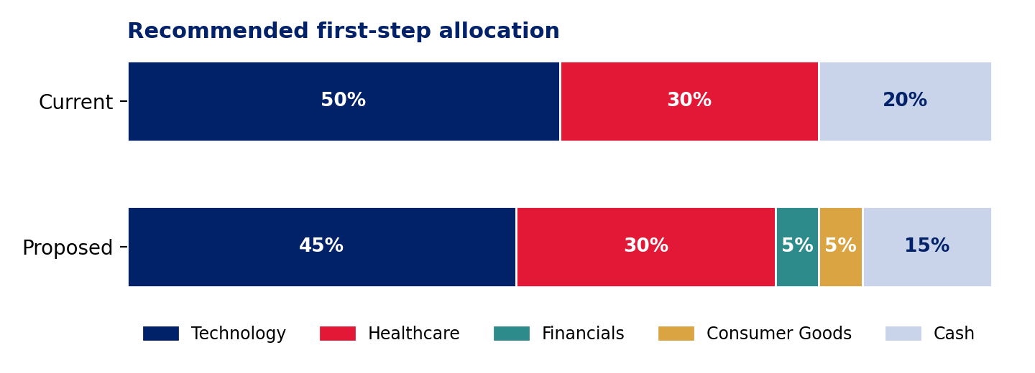
Figure 1. Current versus proposed allocation.
Priority | Action | Rationale
Now (0–4 weeks) | Rebalance to 45% technology, 30% healthcare, 5% financials, 5% consumer goods and 15% cash. | Reduces reliance on one sector while keeping technology as the growth core. On the past year’s average returns the switch is roughly return-neutral (about −0.03 points per quarter, illustrative). In the stress window it would have cut the portfolio’s loss from about 1.0% to about 0.85–0.9%.
Now | Hold the 15% cash reserve in short-duration, high-quality instruments such as Treasury bills or money-market funds. | Keeps liquidity for opportunities while earning more as rates rise. Directly addresses the client’s rate concern.
Now | When trimming technology, favour profitable, cash-generative companies with low debt. | Rate hikes weigh most on companies that rely on borrowing to fund growth. Company-level screening is outside the data provided.
Next 1–3 months (triggers) | Escalation rule: if the VIX holds above 25 for two consecutive weeks, or technology falls a further 3% from the rebalancing date, cut technology to 40% and split the 5 points between healthcare and consumer goods. | The VIX peak of 25 coincided with technology’s worst week. Pre-agreed rules avoid emotional decisions in stressed markets.
Next 1–3 months (triggers) | Opportunity rule: if technology pulls back while the VIX stays below 25 and earnings hold, deploy up to 3 points of cash in three equal tranches, never taking technology above 50%. | Sells into strength now and buys weakness gradually later, rather than trying to time the bottom.
Watchlist | Do not allocate to energy yet. If a quarterly return confirms the recent weekly recovery, add a capped starter position of up to 3% from cash, in tranches. | Weekly returns improved but the last two quarters were negative, and energy is the most volatile sector on the quarterly data (standard deviation about 4.5 points). That conflicts with the client’s aversion to highly volatile investments, but energy’s tendency to move against technology justifies a small, capped position once confirmed.
Long term (5–10 years) | Review quarterly within tolerance bands: technology 40–50%, healthcare 25–35%, cash 10–20%. Add a measure of how strongly the portfolio moves with the overall market (portfolio beta) to the monitoring set. | Keeps the portfolio aligned with long-term growth without over-trading. Portfolio beta could not be calculated from the data provided.

Risks to these recommendations
- Cost of trimming: if technology keeps delivering last year’s average of about 5% a quarter, each 5 points moved into steadier sectors gives up roughly 0.12 points of portfolio return per quarter.
- Financials are ballast, not a hedge: they moved almost in lockstep with technology in the sample, only with smaller swings.
- Consumer goods is untested in sell-offs: the weekly file has no consumer goods series, so its behaviour under stress is not verified here.
- Short samples: seven weeks and four quarters cannot establish causes, which is why the plan is staged and rule-based.

Supporting Data and Visualizations
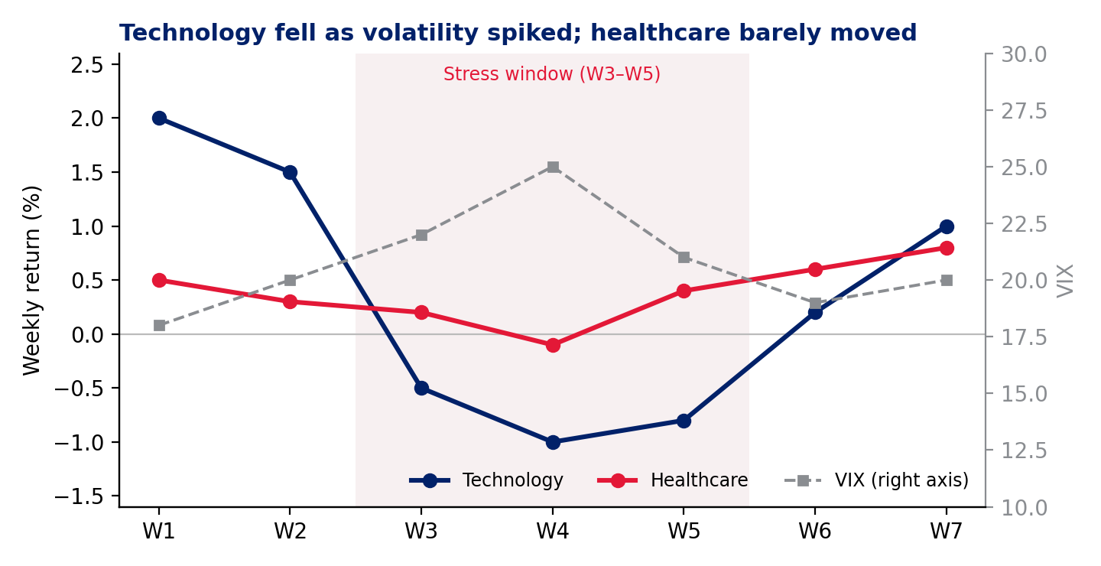
Figure 2. Technology versus healthcare weekly returns, with the VIX. The shaded band marks weeks 3 to 5, when technology fell as volatility peaked while healthcare stayed close to flat.
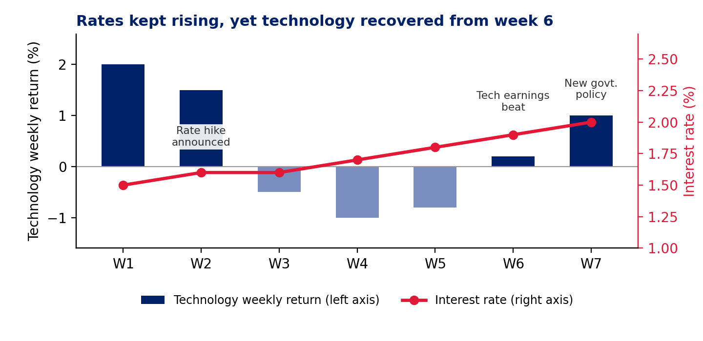
Figure 3. Interest rate versus technology’s weekly return. The rate rose in five of six steps and never fell, yet technology recovered in weeks 6–7, suggesting earnings, policy and sentiment mattered more than rates in this window.
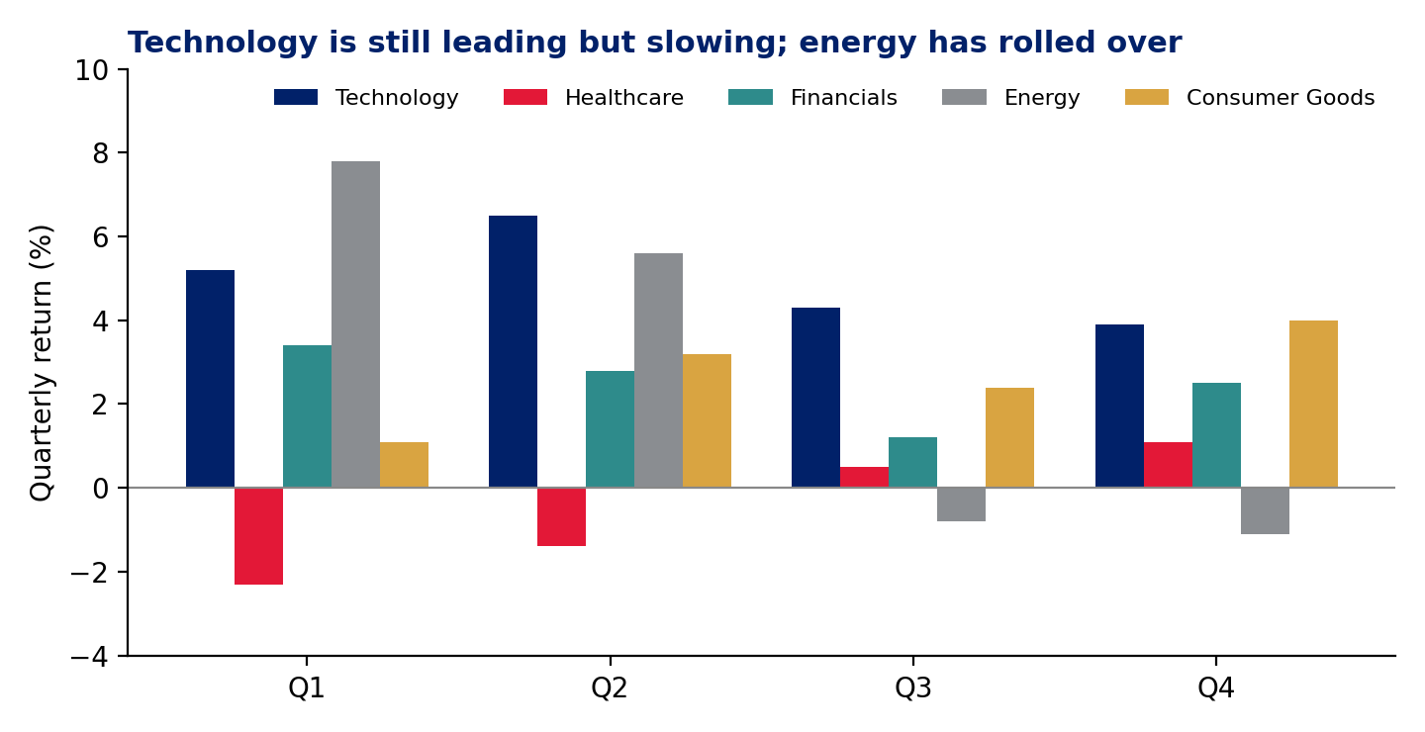
Figure 4. Quarterly sector returns. Technology leads for the year but is slowing, healthcare is recovering from two negative quarters, and energy has turned negative.

Data notes and limitations
- The weekly file has seven observations; the toolkit has four quarters and four monthly rate readings. They are treated as separate lenses (recent weeks versus the prior year) and not blended, because their time scales and rate levels (1.5–2.0% versus 2.5–3.25%) differ and they can disagree.
- Correlations and volatilities from so few points are indicative, not statistically robust. The stress-window estimate for the proposed mix assumes consumer goods behaved like financials, which the data cannot confirm.
- The stress-window test treats cash as flat, and the cost comparison assumes cash earns about 2.9% a year (the midpoint of the toolkit’s rate series). Trading costs and taxes are ignored. Results are historical illustrations, not forecasts.

Closing Remarks
Emerald’s portfolio is fundamentally sound for a growth-oriented investor, but it is riskier than its moderate risk profile suggests because one sector drives nearly all of its variability. The recent data show that volatility, not the rate path alone, is the immediate threat, that healthcare cushions but does not lead, and that technology remains the growth engine even as its momentum slows. A staged rebalance with clear, pre-agreed triggers addresses the concentration without sacrificing the growth objective.
Suggested next steps:
- Approve the first-step rebalance and the placement of the cash reserve in short-duration instruments.
- Agree the escalation and opportunity triggers in writing so they can be executed without delay.
- Schedule a follow-up in 30 days to review the VIX, the rate path and technology earnings momentum.
- Provide holdings data to refine the plan to company level.

